**Retirement and Replacements**

This is Professor Abe Igelfeld’s final semester in his current position. His retirement, results in need for individuals to fill the roles of:

* Transfer Credit Assessment liaison with the Transfer Credit Office – Alfonso Gracia-Saz?
* Department Representative on Scholarship review panels and the Department liaison with the Faculty of Arts and Science – Alfonso Gracia-Saz?
* Manager, Teaching Assistants Positions – Jason Siefken?
* Instructor and Coordinator – MAT133Y1 – (??)

**Learning Management System**

A new Learning Management System QUERCUS, replaces Portal/Blackboard, at the start of the next academic year, 2018-2019. Faculty, staff and all instructors are encouraged to:

* Attend training sessions
* Export old data from Portal/Blackboard to Quercus
* Back up old data from Portal/Blackboard on secured Math Department directories

We are requesting for two volunteers who will choose to be trained, and act as resource personnel during this learning curve.

**New Courses**

The following new courses were offered, this academic year 2017-2018.

* Mathematical Method in Data Science, MAT245H1, taught by Professor Nicholas Hoell, closed with 18 students
* Number Theory for Specialist Students, MAT382H1 taught by Professor Jacob Tsimerman closed with 8 students
* Mathematical Modelling, MAT482H1 taught by Professor Adam Stinchombe closed with 15 students

**Increasing FCEs**

The amount of full course equivalents taught by the Department of Mathematics continues to increase.



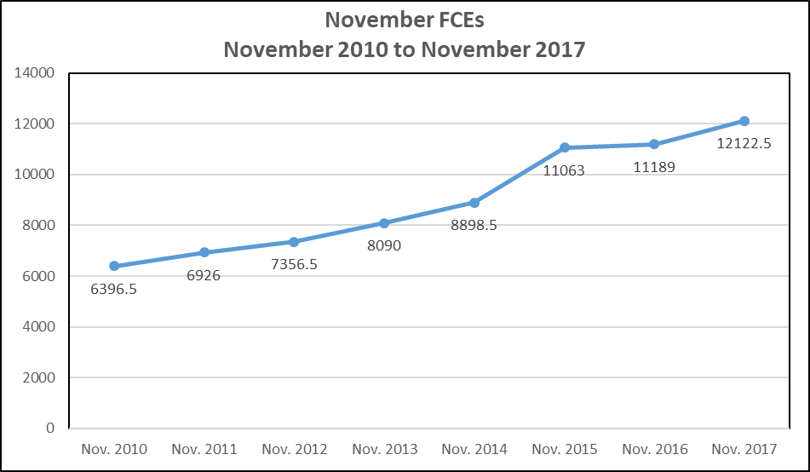

**NSERC Awards**

The Department received seven awards for Summer 2018. The details are displayed in the table below:



**Work Study Opportunity**

Initiated by Professor Kasra Rafi, with the Chairs, approval, request was made for four Math Research Intern Workstudy positions for Summer 2018. All four positions were approved.

**Undergraduate Math Competition**

The University of Toronto, Undergraduate Mathematics Competition was held on Saturday, March 10, 2018. As a result of Professor Barbeau’s dedicated commitment, this annual event convened for the 18th year. Students wrote the competition at two locations, St. George and at the UTSC campuses. The top three students listed in ranking order are:

1. Michael Chow (IV Math)

2. Itai Bar-Natan (IV Math)

3. Andrew Gomes (IV Math/Phys)

*****************************

I Honorable Mention (listed in alphabetical order)

* Andrey Khesin (III Math/Phys)
* Jianing Li (II EngSci)
* Dmitry Paramonov (III CSc)

*****************************

II Honorable Mention (listed in alphabetical order)

* Rafael Aznar (III Math)
* Lian Patinaan (UTSC)
* Richard Chow (II AppMat)
* Xincheng Zhang (UTSC)

**PUTNAM Math Competition**

The persistent hard work of the students and their supervisors, Professor Bernardo Galvao-Sousa and Professor Alfonso Gracia-Saz resulted in the achievement of fourth place in the Seventy-Eighth William PUTNAM competition.

The rankings were:

1. Massachusetts Institute of Technology
2. Harvard University
3. Princeton University
4. University of Toronto
5. University of California at Los Angeles

**Performance in First Year Courses**

The following charts data provides an update on the performance of in the selected first year math courses. The average and median indicators show similar amounts across the courses. Appendix II provides a detailed look at the average and median scores in the first year courses for the past five years.



Please note that although the class sizes show reduction in numbers between the Fall and 2016 and Fall 2017 enrolment continues to increase. These reductions account for the number of students who actually ends the courses. Therefore, in Fall 2017 we had fewer students completing MAT136, MAT223 and MAT224 than we had in the same period in the previous year. Appendix III displays additional marks distribution tables for the last five years.

This semester, the number of students who have dropped from many of the mathematics courses reached a record high in some courses. We have asked the faculty for the data on the changes in enrolment from the start to the end of the courses for several years so that we will be able to identify trends.







**Undergraduate Student Development Activities**

**Mentorship**

* The 2017-2018 undergraduate mentorship program included the following activities:
  + Mentee Launch event, October 2017
  + MentorConnect Event, January 2018
  + MentorshipMarch, March 2018 – During this month mentors invited their student mentees into their work environment for practice interviews and feedback on their résumé
  + Closing Activity, May 2018

**Academic Integrity Session**

* Officers from the Office of Student Academic Integrity conducted two information sessions for undergraduate students during the fall term.

**Backpack to Briefcase (B2B)**

* The Department of Mathematics partnered with the Faculty of Arts and Sciences in executing the b2B dinner at the Faculty Club in February 2018

**Career in Maths Event**

* Math at Work presentation, executed by Carlo Lisi, Senior Audit Manager, Analytics (TD Bank)
* Careers in Math facilitated by Wei Huang, U of T, Career Centre Educator

**Graduate School Application**

* One graduate school application event was held in each semester. They were facilitated by Professor Burchard, Professor Kim, Professor Rotman and Professor Bar-Natan.

**Orientation – Summer 2018**

* Thank you once again to the instructors and professors who participated in the Summer 2017 Orientation session.

***Participating instructors:***

* + Professor Sarah Mayes-Tang - MAT135H1
  + Professor Alfonso Gracia-Saz – MAT137Y1
  + Professor Joe Repka – MAT157Y1
  + Professor Nicholas Hoell – MAT223H1
* Volunteers are need for the upcoming Summer 2018 orientation to first-year mathematics sessions in August.

**Note:**

In the interest of saving paper the following Appendixes were removed, but this data may be forwarded upon requests.

1. Appendix I – Feedback Report Summer 2017 Orientation
2. Appendix II–Marks distribution first year courses (5 years)
3. Appendix III – Mean and averages in first year courses (5 Years)