**First Year Course Coordinators**

The Department of Mathematics welcomed new staff members who have assumed coordination duties for some of the largest courses in the undergraduate program. These individuals along with some of the others who have done this before worked hard to enable a smooth start to the semester, adjusting schedules, classrooms and demands in order to utilize the limited resources. Thanks to:

Abe Igelfeld – MAT133Y1Y 906

Sarah Mayes-Tang - MAT135H1F 2605

Alfonso Gracia-Saz- MAT137Y1Y 1258

Joe Repka - MAT157Y1Y 186

Nicholas Hoell – MAT223H1F 1483

Eckhard Meinrenken – MAT240H1F 191

**Large second term first-year courses:**

Nicholas Hoell – MAT223H1 S 735

Jason Siefken – MAT224H1S 910

Steve Kudla – MAT247H1S 200

**More Data On the Teaching**

There are 158 lecture sections for 2017-2018 Faculty of Arts and Science courses, including four first year seminar courses and 48 lecture sections of Engineering courses.



Summer Lecture Sections



**Teaching Categories**

Professors account for the largest group of instructors.

* Professors: 37
* Retired Professors: 2
* Lecturers: 7
* Graduate Students: 31
* Postdoctoral Fellows: 23
* Unit 3 & Cox: 3

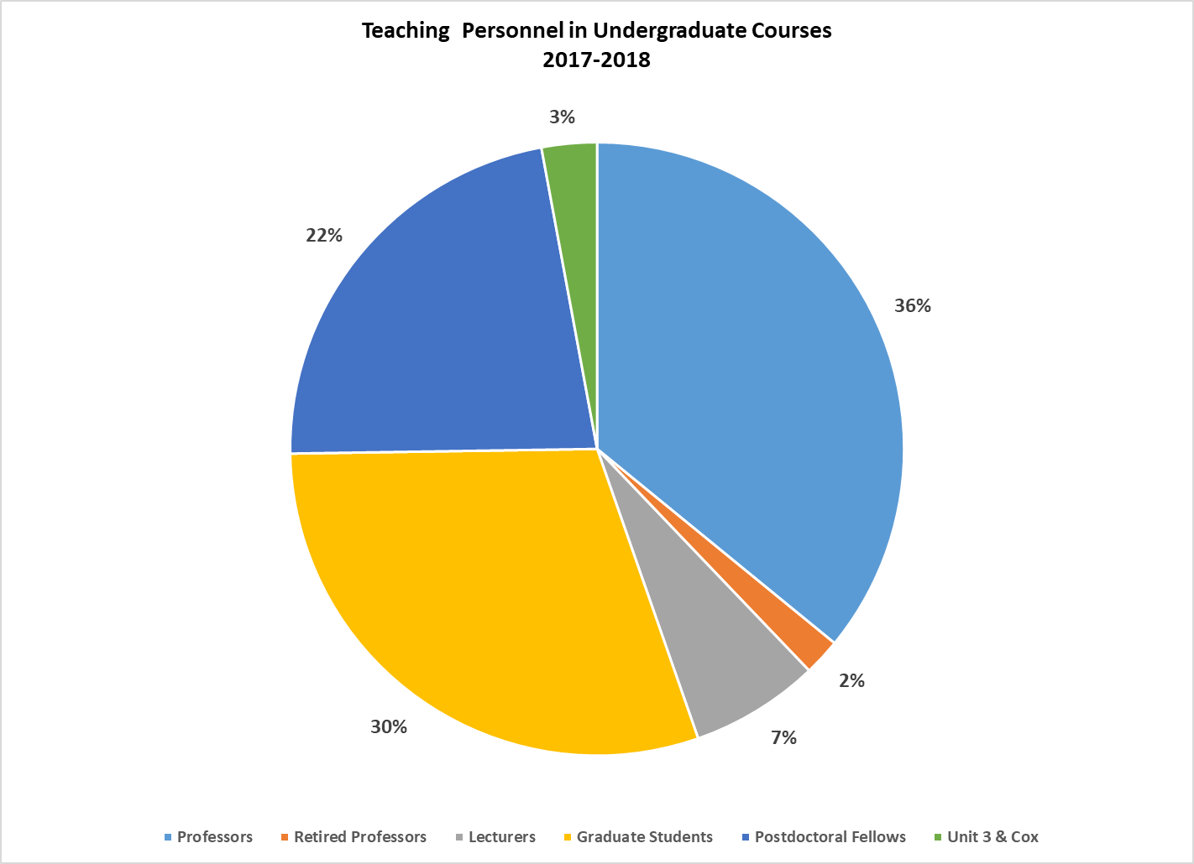

**Program Enrolment**

This year the Department of Mathematics is the second largest department in terms of students who are doing a specialist, major or minor with 3153 students registered students. The Statistics Department moved into first place this year with a grand total of 3937.

How do our numbers compare with some of the other science departments?

1. Human Biology 3003
2. Commerce 2027
3. Computer Science 2383
4. Economics 1981
5. English 1895
6. Physics 520
7. Chemistry 465

**Comparison with Last year’s numbers**

Growth was experienced by the quantitative science programs: Statistics, Math, Computer Science and Commerce. Statistics grew by 712, they had 3,225 students in their program last year, Computer science increased by 212, Math moved up by 296 students and Commerce grew by 73. There was a reduction in enrolment in Human Biology, Physics, Chemistry and English programs. Human Biology fell from 3,118 by 115, Physics fell by 19 and Chemistry fell by 15 and English fell by 254.

How does this year’s program enrolment compare to previous years?



**Growth in Math Enrolment**

Ten years ago the department had less than 1000 students registered in programs that amount has more than tripled. Although we continue to grow, the rate of growth has been slowing over the last four sessions.

* Fall 2017 – Growth of 10% over the previous fall session
* Fall 2016 – Growth of 12% over the previous fall session
* Fall 2015 – Growth of 28% over the previous fall session
* Fall 2014 – Growth of 34% over the previous fall session

We’ve certainly seen growth in our own program over the years. Changes in the demand for math in other programs have also led to larger enrolment numbers in math courses.

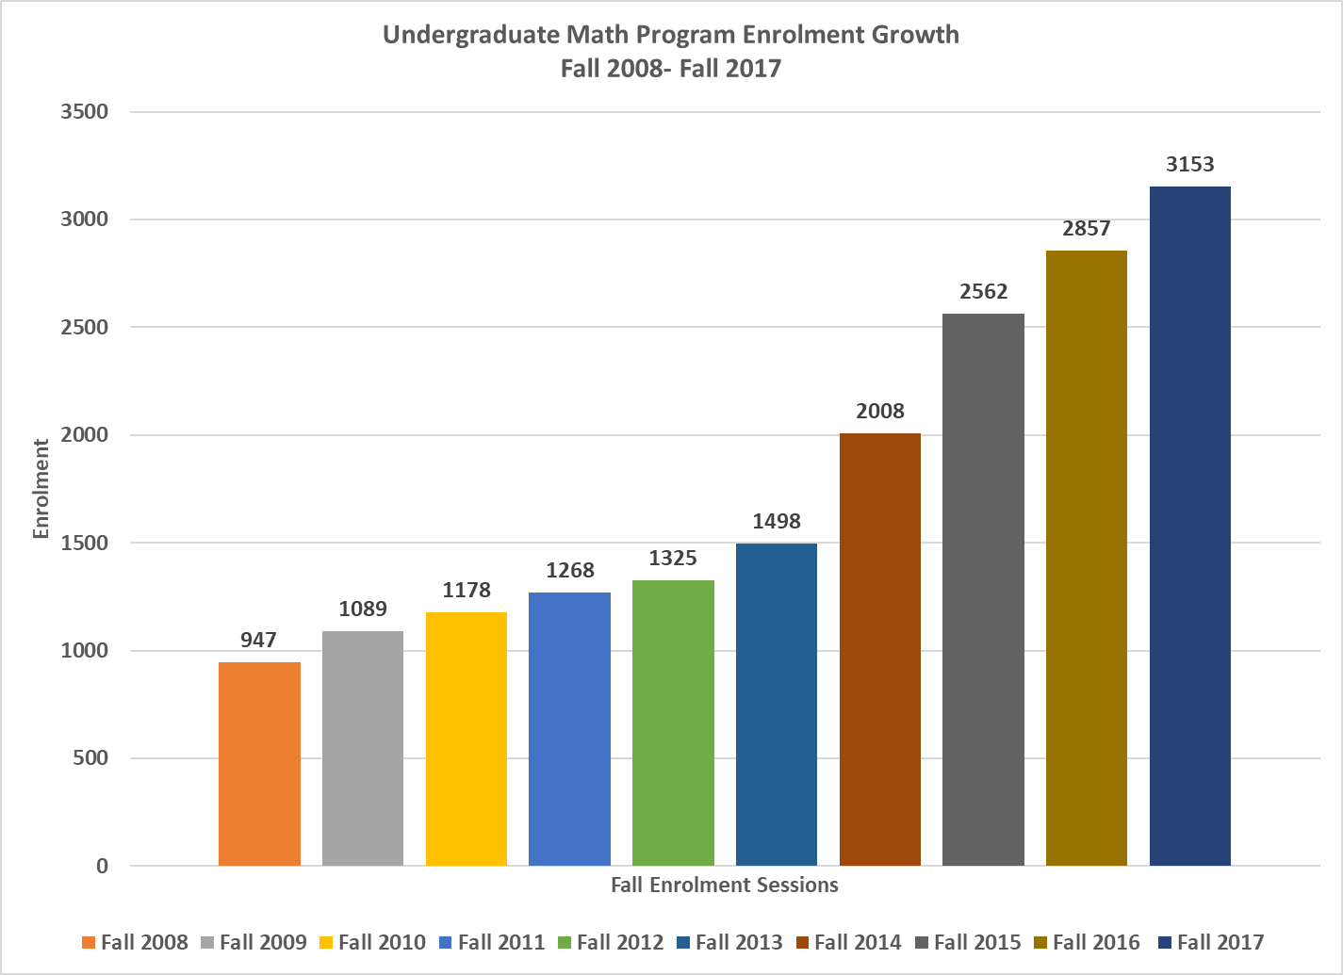

**How Many Students Are Taking our Courses?**

The data in the table below shows the number of enrollments in courses by some of the FAS departments as of February 1, 2017. In February, Mathematics courses accounted for the largest percent of Total Arts Sci. teaching, by any department. Please note that **this does not include our teaching for engineering.**

FAS Sessional Report on Enrolment as per Administrative Organization

| **Department** | **Abbreviation** | **Number of Students** | **FCE’s** | **% of Total Arts Sci FCEs** |
| --- | --- | --- | --- | --- |
|  |  |  |  |  |
| Anthropology | ANT | 3951 | 2610 | 2.1 |
| Astronomy | AST | 3114 | 1571 | 1.3 |
| Commerce | COMG | 14127 | 7064 | 5.8 |
| Cells and Systems Biology | CSB | 6147 | 3196.5 | 2.6 |
| Chemistry | CHM | 5221 | 2715 | 2.2 |
| Computer Science | CSC | 14697 | 7354.5 | 6.0 |
| ECO | ECO | 11223 | 8806 | 7.2 |
| Ecology and Evolutionary Biology | EEB | 5456 | 2749.5 | 2.3 |
| English | ENG | 5339 | 3769 | 3.1 |
| History | HIS | 5895 | 3870 | 3.2 |
| Human Biology | HMB | 4924 | 2516.5 | 2.1 |
| Mathematics | MAT | 17175 | 10416.5 | 8.5 |
| Philosophy | PHL | 6684 | 3813.5 | 3.1 |
| Psychology | PSY | 9453 | 4763 | 3.9 |
| Physics | PHY | 4517 | 2266.5 | 1.9 |
| Sociology | SOC | 6915 | 3922 | 3.2 |
| Statistics | STAT | 8523 | 4273.5 | 3.5 |

The FAS enrolment data for fall 2017 will become available in November.

**Enrolment by Gender**

The enrolment by gender data does not account for all the students enrolled in the programs since some students did not declare a gender; 1756 of them declared male as their gender and 1389 declared female as their gender.

In fall 2015 the number of males in the program stood at 57.7%, in fall 2016 the number of males in the program moved to 57% and this year the males account for 56%.

**International Student Enrolment in Programs**

The number of international students in the program has quadrupled between 2011 and 2017. International students now account for 49% of the total number of students enrolled in mathematics programs.



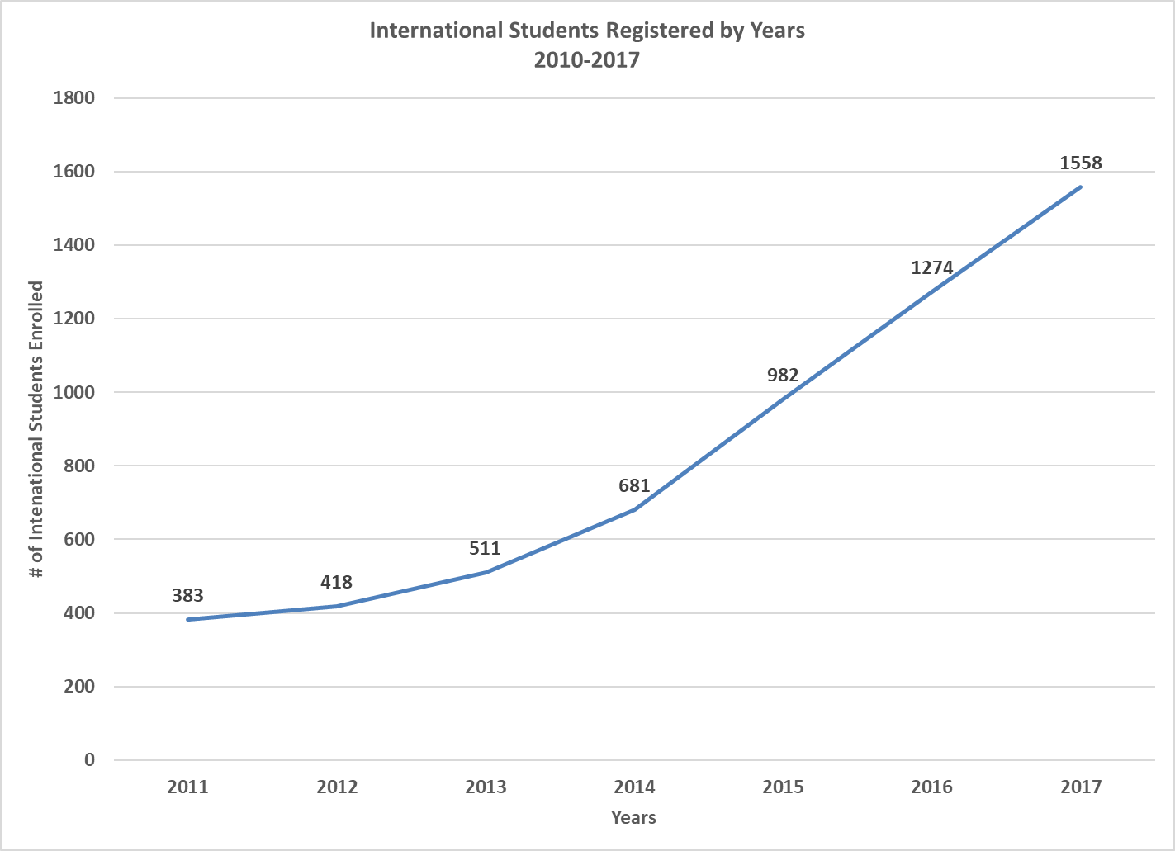

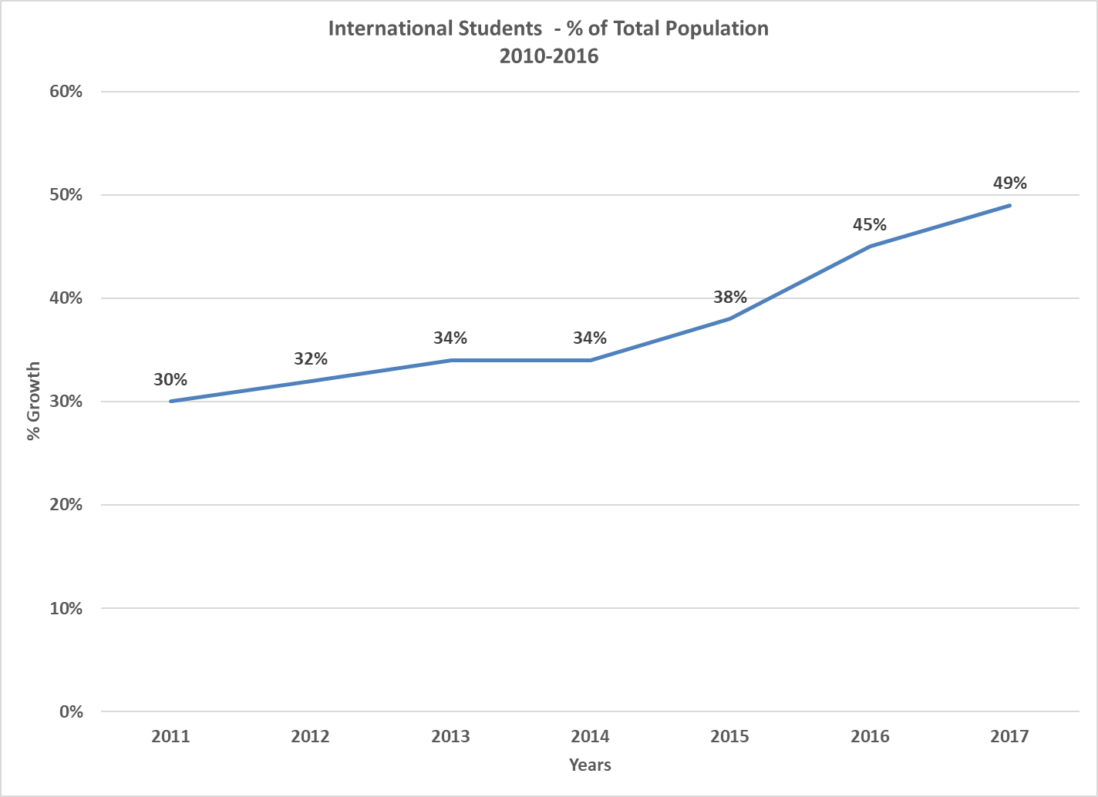

**Graduates 2016-2017**

The Faculty of Arts and Science has confirmed that math majors, specialist and minors accounted for 411 graduates for November 2016 and June 2017. The table show the breakdown by program.

| **Program of Study** | **November 2017** | **June 2017** |
| --- | --- | --- |
| Math Major | 32 | 101 |
| Math Minor | 27 | 153 |
| *Sp: Math & Physics* | 2 | 8 |
| *Sp: Mathematics* | 0 | 11 |
| *Sp: Math & Philosophy* | 0 | 1 |
| Sp: Math & its Appl. Teaching | 0 | 4 |
| Sp: Math. Appl. to Econ & Finance | 6 | 47 |
| Sp: Math & its Appl. Physical Sci. | 0 | 1 |
| Sp: Math & its Appl. Prob. & Stats. | 1 | 14 |
| *Sp: Applied Mathematics* | 0 | 3 |
| Total | 68 | 343 |

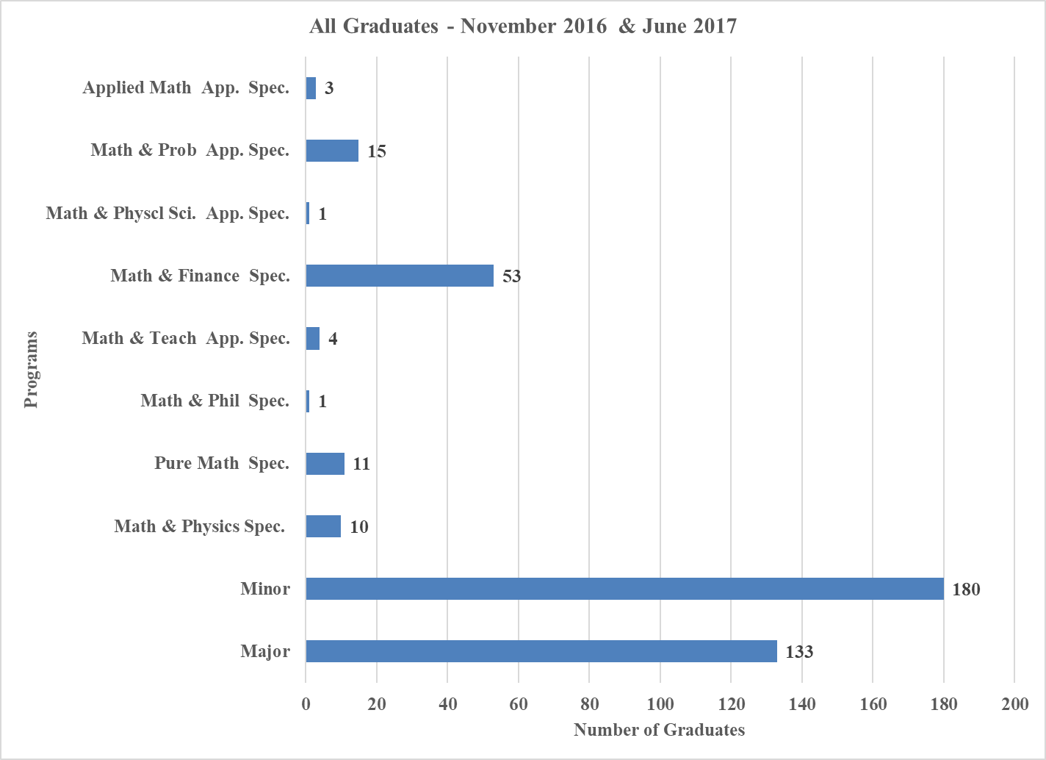

**Other Undergraduate Activities**

The undergraduate office continues to execute programs that focus on the enhancement of the undergraduate students’ experience.

* First Year Orientation Sessions – We held two sets of orientation sessions July and August. Sincere thanks to Anup Dixit, Jill Tate, Prof. Sarah Mayes-Tang, Prof. Gracia-Saz, Prof. Joe Repka, Prof. Jacob Tsimerman and Prof. Nicholas Hoell who took the time to attend, counsel and/or demonstrate actual math content of the courses so that students could obtain a preview of the material in the course.
* We received several requests for the sessions to be captured on video so that it could then be made available to the international students and other students who were interested in sharing the experience but who could not attend the session
* 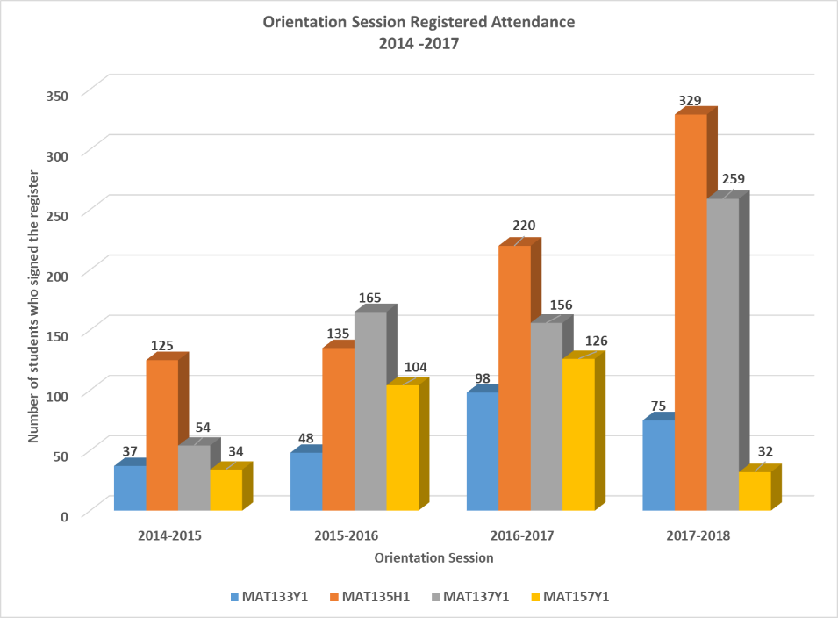The chart below, shows the growth in attendance in these sessions over the past four years. The number of students providing feedback has also grown and a detailed report on their feedback will be completed at a later date.
* Mentorship connections – Mentorship connections will be kept at 46-50 pairs for 2017-2018. The mentee launch event is scheduled for this Thursday, October 26, 2017 and the MentorConnect session will take place in November.

We are inviting faculty members to volunteer as mentors for undergraduates who are exploring the possibility of careers in mathematical research.

* Peer Study Teams (PST) – The Faculty of Arts and Science has included MAT157Y, MAT240H1 and MAT247H1 in their Peer Study Team Project. Students access additional math help for these courses through this program.
* Co-Curricular Credits were assigned to all the students who wrote the PUTNAM competition and the volunteers in the Mathmakers Activity.
* First-year Learning Communities – The MAT137Y and MAT157Y1 FLC communities are currently thriving with faculty supervision from Professor Joe Repka and Joel Kamnitzer. The peer leader for MAT157Y1 is Jordan Hoffman, she is assisted by Chengjin Liu while the MAT137Y1 FLC is being led by Yunjing Li who is assisted by Shawn Soobramanie.
* Undergraduate Math Competition was held on March 12, 2017. The results were as follows:
  + Michael Chow – 1st place
  + Shuyang Shen – 2nd place
  + Rafael Aznar – 3rd place
  + Andrey Khesin – 4th place
  + Dmitry Paramonov and Jiangtian Yao – 5th place
* b2B – Backpack to Briefcase

FAS plans and execute career focused sessions for students in the mathematical sciences the students are usually encouraged to register through the undergraduate blog and e-mail reminders.

* Mathmakers Club

The format of the Mathmakers Club was changed for the 2016-2017 academic year. The activities were scheduled for the first six weeks in the first and second semester and for the first time, the final graduation activities were held at Lord Lansdowne Public School. Prof. Kumar Murty and Prof. Mary Pugh attended and issued the certificates to the eager participants

* + 46 students were registered in the program
  + The U of T student volunteers were all members of the Concepts of Elementary Math, MAT329Y1, course
* Math Union

The 2017-2018 leaders for the Mathematics Union are:

* + President – Calder Morton-Ferguson
  + Secretary – Heather McBrien
  + Treasurer – Vincent Huang
  + Vice President (Communications) – Abhishek Moturu
  + Vice President (Academics) – Jessica Liu
  + Vice President (Social) – Noelle Huang

Calder and Abhishek, are also the current undergraduate representatives on the Undergraduate Committee.

* We request your continued participation in these undergraduate activities as we continue to work on improving the students’ experience.

**Appendices**[1]

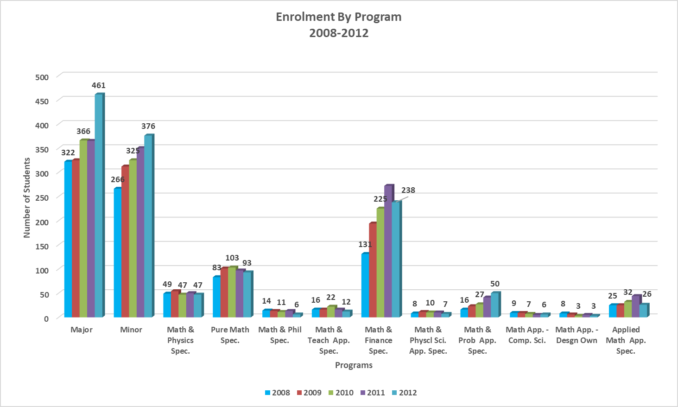

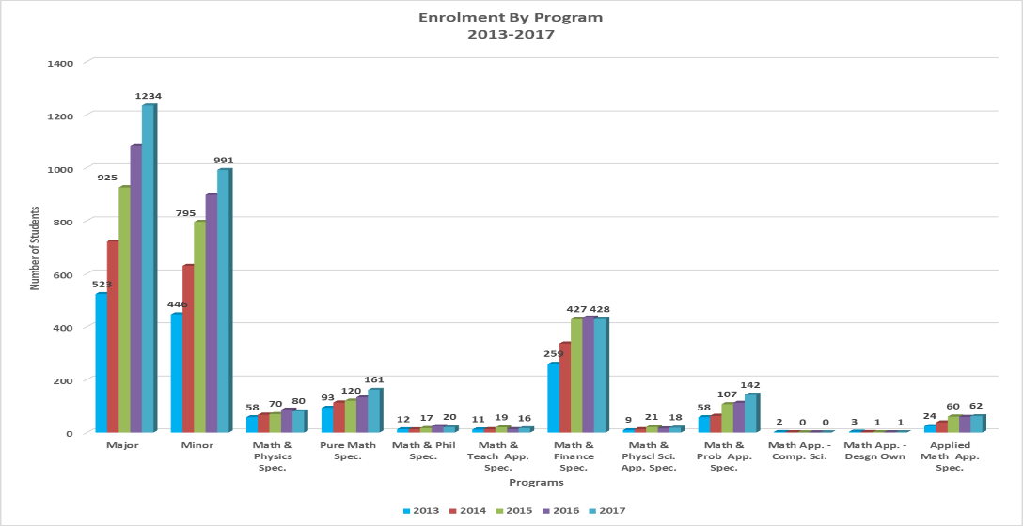

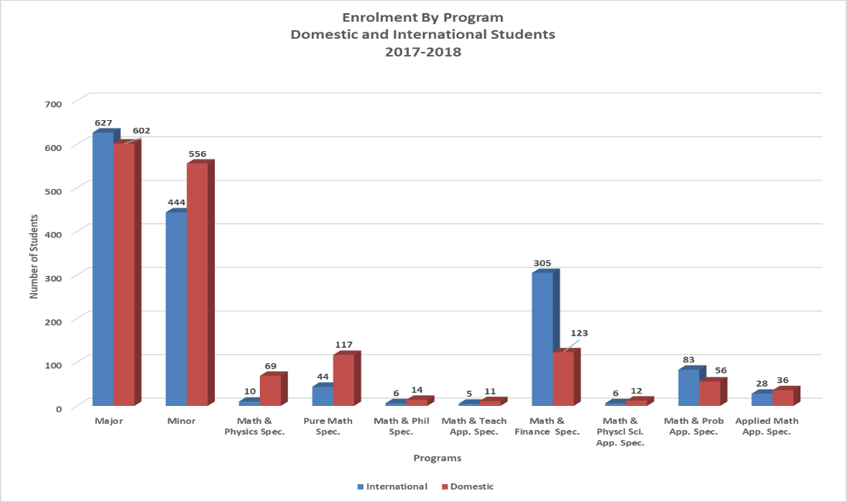

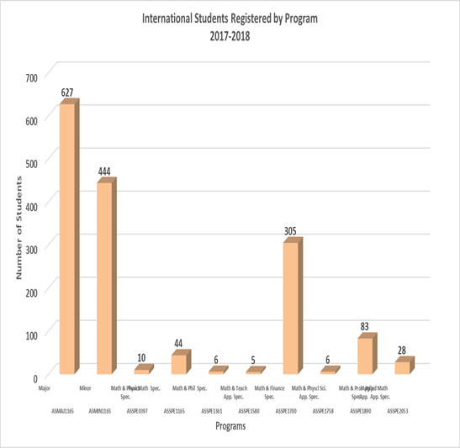

1. The October 2, 2017 data for domestic and international enrolment was 3154