Summary of CRM Activity
“Algèbres de Lie et Invariants” / “Lie Algebras and Invariants”, July 2019
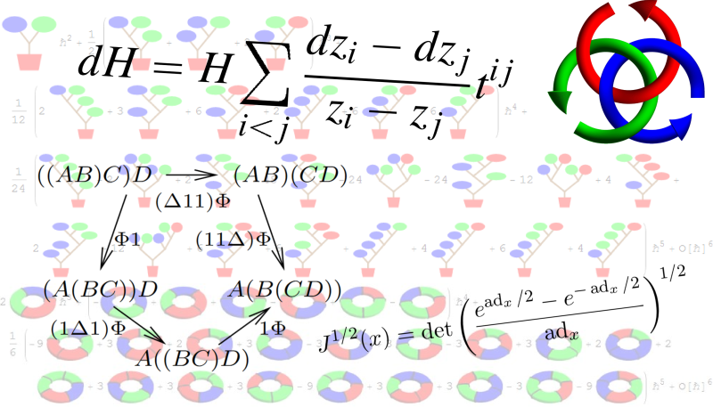
Agenda (as advertised in advance of the activity). Our workshop will bring together a number of experts working on "expansions" and a number of experts working on "invariants" in the hope that the two groups will learn from each other and influence each other. "Expansions" are solutions of a certain type of intricate equations within graded spaces often associated with free Lie algebras; they include Drinfel'd associators, solutions of the Kashiwara-Vergne equations, solutions of various deformation quantization problems, and more. By "invariants" we refer to quantum-algebra-inspired invariants of various objects within low-dimensional topology; these are often associated with various semi-simple Lie algebras. The two subjects were born together in the early days of quantum group theory, but have to a large extent evolved separately. We believe there is much to gain by bringing the two together again.
Organizers. Anton Alekseev (Geneva), Dror Bar-Natan (Toronto), and Roland van der Veen (Leiden, now Groningen).
Speakers (in order of appearance). Dror Bar-Natan (Toronto), Anton Alekseev (Geneva), Florian Naef (MIT), Roland van der Veen (Leiden, now Groningen)., Leila Schneps (Paris), Gwenael Massuyeau (Bourgogne), Adam Sikora (Buffalo), Tetsuya Ito (Kyoto), Dylan Thurston (Bloomington), Ulf Kuehn (Hamburg), Delphine Moussard (Marseille), François Costantino (Toulouse), Marcy Robertson (Melbourne), Pavol Severa (Geneva), Yusuke Kuno (Tokyo), Sakie Suzuki (Tokyo), Zsuzsanna Dancso (Sydney), Travis Ens (Toronto), Thang Le (Atlanta), Nariya Kawazumi (Tokyo), Jun Murakami (Tokyo), Brant Pym (Montreal), Hidekazu Furusho (Nagoya), and Benjamin Enriquez (Strassbourg).
Participants. We had a total of 27 participants.
Summary of Activities. The best summary of our activities is the workshop’s web site, at http://drorbn.net/crm19 (and also attached as a PDF file). It contains the full schedule of activities, the titles and abstracts of all lectures given, video links for most lectures, and more.
In short, on the first week Bar-Natan, Alekseev, Naef, van der Veen, and Schneps gave long introductory lectures on foundational topics for our field, with titles “Expansions, Lie algebras and Invariants”, “Goldman brackets, Turaev cobrackets and formality”, “Formality of string topology in dimensions ≥2 and Kashiwara-Vergne”, “Universal invariants and quasi-triangular Hopf algebras and Polynomial time knot invariants”, and “The mould theory approach to multiple zetas and The mould theory approach to Kashiwara-Vergne and The mould theory approach to elliptic multizetas and Kashiwara-Vergne”.
The second week was conference-style, with a total of 14 lectures. We aimed to give each speaker at least 90 minutes to allow each lecture to provide an in-depth development of a research topic.
The rest of the month, another two and a half weeks, was “workshop style”, with a lot of free time for the participants to interact, exchange ideas, and make research progress. Yet almost every day we had at least one participant give an even longer lecture or a pair of lectures, at an even greater depth.
Some of our participants were in the early stages of their careers, as graduate students or post-docs (including Travis Ens, Quentin Faes, Jesse Frohlich, Delphine Moussard, Florian Naef, and Nancy Scherich). We believe we made a great and lasting contribution to the professional development of these people.

