MAT 188
Moved to
RS 211
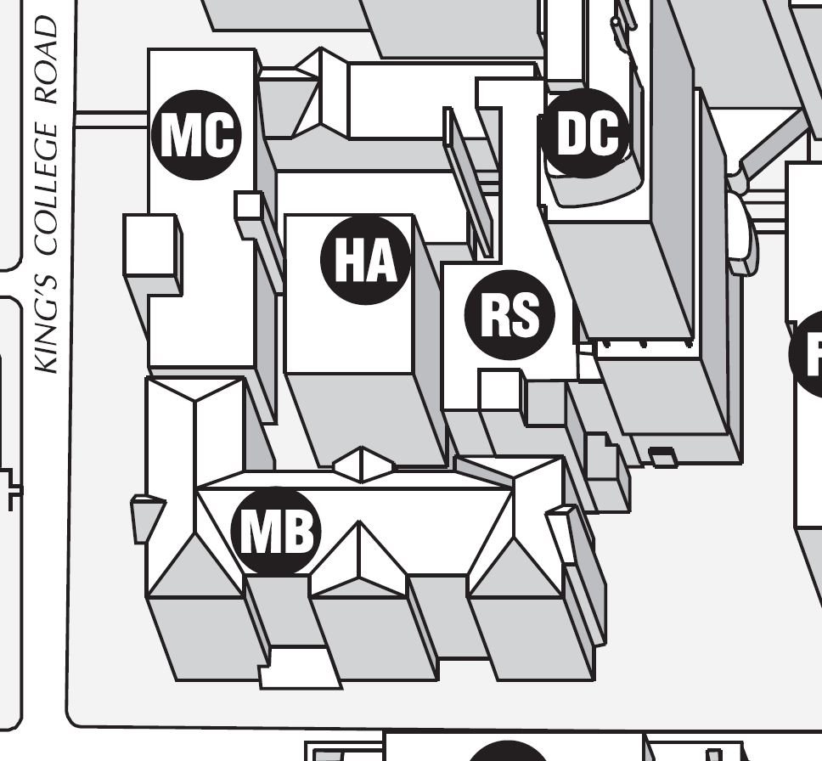
For the rest of this semester

