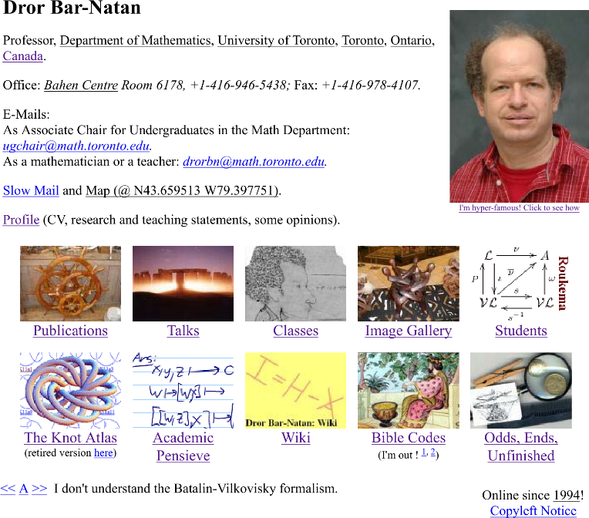
Dror Bar-Natan
Two Page CV
October 16, 2019
Email: drorbn@math.toronto.edu.
web: http://www.math.toronto.edu/drorbn.
Age now: 53. Born January 30th, 1966. Holds Israeli, US, and Canadian citizenships.
1982-1984: B.Sc. in mathematics, Tel Aviv University, summa cum laude.
1984-1987: Military service (taught high school level mathematics).
1987-1991: Ph.D. in mathematics, Princeton University. Title: Perturbative aspects of the Chern-Simons topological quantum field theory. Advisor: Professor Edward Witten.
1991-1995: Benjamin Peirce Assistant Professor at Harvard University.
1995-1997: Senior Lecturer of Mathematics at the Hebrew University, Jerusalem.
1997-2004: Associate Professor of Mathematics at the Hebrew University, Jerusalem.
1999-2000: On sabbatical in Berkeley; fall semester as “Visiting Miller Professor” at the University of California, spring semester at MSRI.
2002-2006: Associate Professor of Mathematics at the University of Toronto.
Since July 2006: Professor of Mathematics at the University of Toronto.
Current Grant: NSERC Discovery, Poly-Time Knot Theory and Quantum Algebra, (2018–2023, CDN$140,000).
10 Career Best Publications:
- On the Vassiliev Knot Invariants, Topology 34 (1995) 423–472. (Reported at the prestigious Séminaire Bourbaki. See P. Vogel, Invariants de Vassiliev des nœuds [d’après D. Bar-Natan, M. Kontsevich et V. A.Vassiliev], Séminaire Bourbaki 761 (1993) 1–17 & Asterisque 216 (1993) 213–232).
- With S. Garoufalidis, On the Melvin-Morton-Rozansky Conjecture, Inventiones Mathematicae 125 (1996) 103–133.
- On Associators and the Grothendieck-Teichmüller Group, Selecta Mathematica (New Series) 4 (1998) 183–212.
- With S. Garoufalidis, L. Rozansky, and D. P. Thurston, The Århus Integral of Rational Homology 3-Spheres I: A Highly Non Trivial Flat Connection on S³, Selecta Mathematica, New Series 8 (2002) 315–339.
- With B. McKay, M. Bar-Hillel and G. Kalai, Solving the Bible Code Puzzle, Statistical Science 14-2 (1999) 150–173.
- With T. Q. T. Le and D. P. Thurston, Two Applications of Elementary Knot Theory to Lie Algebras and Vassiliev Invariants, Geometry and Topology 7-1 (2003) 1–31.
- Khovanov’s Homology for Tangles and Cobordisms, Geometry and Topology 9-33 (2005) 1443–1499.
- Balloons and Hoops and their Universal Finite Type Invariant, BF Theory, and an Ultimate Alexander Invariant, Acta Mathematica Vietnamica 40-2 (2015) 271–329.
- With Z. Dancso, Finite Type Invariants of W-Knotted Objects II: Tangles, Foams, and the Kashiwara-Vergne Problem, Mathematische Annalen 367 (2017) 1517-1586.
- With R. van der Veen, A Polynomial Time Knot Polynomial, Proc. Amer. Math. Soc. 147 (2019) 377–397.
Talks. Over the past 20 years I have given several hundred research presentations across the globe. See http://www.math.toronto.edu/~drorbn/Talks/.
Collaborations. I maintain active research collaborations with Anton Alekseev of Geneva, Zsuzsanna Dancso of Sydney, Dylan Thurston of Indiana, and Roland van der Veen of Groningen.
Students. Over the years I had approximately 40 research supervision relationships with students at all levels, including about 15 PhD students. See a partial description at http://www.math.toronto.edu/~drorbn/Students/.
This document is at http://drorbn.net/AcademicPensieve/2019-10/.
A full version of my CV is at http://www.math.toronto.edu/~drorbn/Profile/.

