University of Toronto – Department of Mathematics
Quick Summary for NUDT visit, May 2014
http://drorbn.net/AcademicPensieve/2014-05/DepartmentOfMathematics.pdf

From a 2013 external review report: “The department of Mathematics at the University of Toronto is an elite academic unit, comparable in strength to the best Mathematics Departments in North America”.
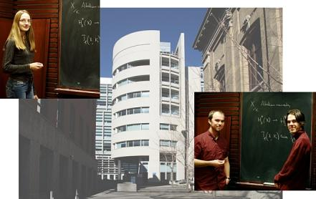
Facilities. Our main location is the 6th floor of the Bahen building, a very modern and comfortable facility that includes a lecture room, a seminar room, computer facilities and a major research library. In addition we have offices in several other locations on campus. We are dreaming of consolidating these locations into a single math building in the not-too-far future.
Undergraduate. We offer a wide range of undergraduate programs, a math ”minor”, a math “major”, a “specialist” program, a specialist program in applied mathematics, and six other specialist programs which are joint with other departments. We have about 500 students enrolled in our various specialist programs, and about 1,200 students counting also majors and minors. We offer about 100 courses each year.
Graduate. We offer an M.Sc. program, a Ph.D. program, and a Masters in Mathematical Finance (MMF) program. We award about 20-25 M.Sc. degrees each year and about 60% of them go on to a Ph.D. program. We award about 12-15 Ph.D. degrees each year, and about 75% of our Ph.D.s go on to University research positions. In total we have about 130 graduate students, and about a quarter of them are international (not from Canada). Our graduate program is funded by a wide variety of sources, including University/government funding, support from the research grants of our faculty, and a very wide variety of external grant support.
Post-doctoral. There are about 20 post-doctoral fellows in our department.
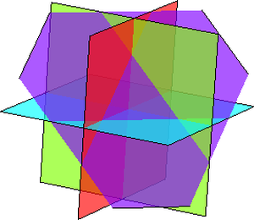
Research. We have an extremely strong research program. We closely collaborate with neighboring departments, Statistics, Computer Science, and Physics, as well as with the Fields Institute which is next door. We have two internal “labs”, RiskLab that deal with mathematical finance, and GANITA that works on information security. Many of our faculty publish in the highest ranking journals. Between 2010 and 2013 our junior faculty won 7 Sloan Foundation Awards, of about 80 given in mathematics in North America. Four of our faculty members (Jim Arthur, Robert Jerrard, Robert McCann, and Balint Virag) will be speaking at the International Congress of Mathematicians this summer in Korea (one plenary). Additional prizes and honours won by our faculty members since 2010 include further lectures at the ICM (3), an invited talk at SIAM, the Coxeter-James Prize (3), an Outstanding Teaching Award, the Andre-Aisenstadt Prize (4), the Andre Lichnerowicz Prize, the Jefferey-Williams Prize (2), the Humboldt Research Award, Fellowship of the Royal Society of Canada, the Fulkerson Prize, the CRM-Fields Institute Prize, the Killam Fellowship, and the Simons Fellowship (3).
Altogether we have about 56 faculty members, representing practically every field of modern mathematics: logic and foundations (3), algebra (3), number theory (6), algebraic and complex geometry (8), geometry (9), topology (2), Lie theory and generalizations (1), analysis and its applications (5), dynamical systems and ODEs (4), partial differential equations (6), mathematical physics (2), probability and statistics (2), combinatorics (2), numerical analysis and scientific computing (1), control theory and optimization (1), and applied mathematics (1).

