**Staff**Abe Igelfeld has retired and the portfolio of teaching assistant assignments, scholarships, transfer credits and coordination of MAYT133Y1 were shared between Jason Siefken, Alfonso Gracia-Saz, Lindsey Shorser and Jill Tate. Ashley has transitioned to the graduate division and we wish her success in her professional pursuits. We welcome Cherylyn Stina, who recently joined the department as the Undergraduate Assistant.

**Start of the Year**  
Enrollment and room bookings were quite chaotic this September with re-arrangement and relocation of class sessions and schedules, but we survived. The current enrollment numbers are lower in some courses than at the same period last year.

|  |  |  |
| --- | --- | --- |
| **Enrollments as per ROSI (2018) & Nov Count 2017[1]** | | |
|  | **2017** | **2018** |
| Lindsey Shorser and Jill Tate – MAT133Y1 | 893 | 950 |
| Sarah Mayes-Tang - MAT135H1F | 2523 | 2184 |
| Alfonso Gracia-Saz- MAT137Y1Y | 1236 | 1371 |
| Joe Repka - MAT157Y1Y | 182 | 192 |
| Jason Siefken – MAT223H1F | 1426 | 1353 |
| Nicholas Hoell – MAT224H1F | 333 | 504 |
| Eckhard Meinrenken – MAT240H1F | 177 | 202 |
| Jason Siefken – MAT223H1S | 775 | 645 |
| Nicholas Hoell – MAT224H1S | 913 | 817 |
| Payman Eskandari – MAT247H1S | 187 | 196 |

Two of the sections of MAT135H1F and MAT136H1S were merged to create one large lecture section and each section will be taught by Professor Mayes-Tang in the Myhal Centre. The Faculty of Engineering also consolidated some of their smaller classes into large lecture sections and two members of staff are scheduled to teach each large engineering lecture sections.

**Teaching FAS Courses - FCE**

* Professors, Associate Professors

& Professors, Teaching Stream 36.5

* Retired Professor 3.5
* Lecturers 15
* Graduate Students 19
* Postdoctoral Fellows 21
* Sessional Lectures 10.5
* Other 6.5

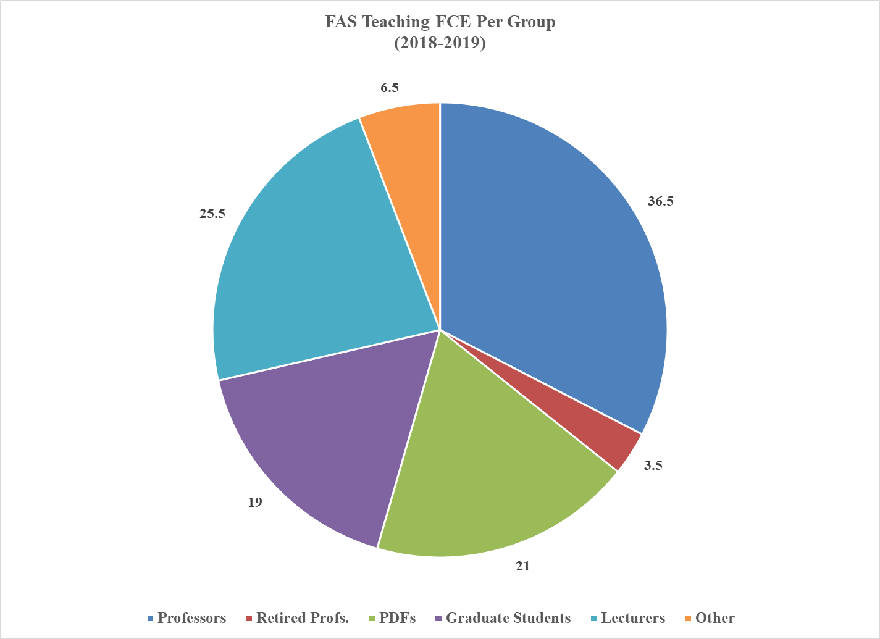

**Teaching Engineering Courses – FCE**The Department of Mathematics scheduled more that 20 FCEs for the fall and winter 2018-2019 engineering math courses. These sections are taught by math staff, PDFs or graduate students and engineering faculty and staff.

**Faculty of Arts & Science Program Enrollments**The Statistics Department remains the largest FAS department with the largest number of students enrolled in programs and the Department of Mathematics remains in second place. Enrollment in statistics program grew by 960 students while math enrollments grew by 311.

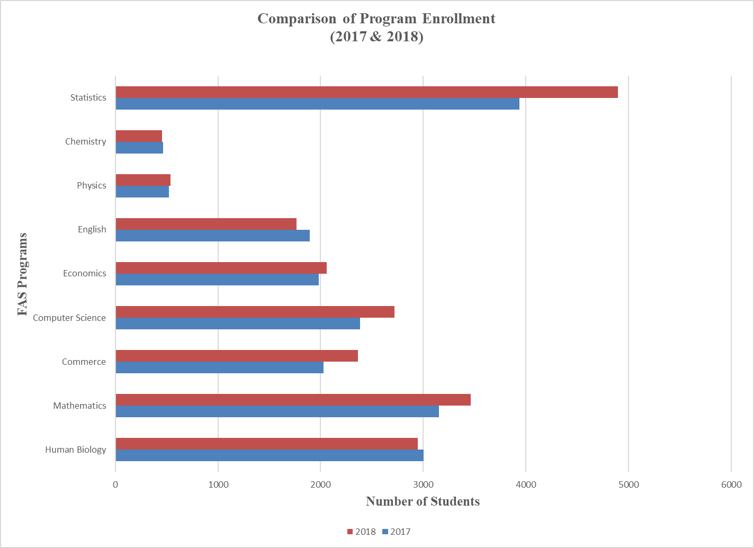

1. Statistics 3937…… 4897
2. Mathematics 3153…… 3464
3. Human Biology 3003…… 2948
4. Commerce 2027 …… 2362
5. Computer Science 2383 …… 2718
6. Economics 1981 …… 2061
7. English 1895 …… 1765
8. Physics 520 …… 536
9. Chemistry 465 …… 454

The breakdown of enrollment in the mathematics programs show that the number of students enrolled in math programs in the second year continues to be significantly higher than students enrolled in mathematics program in the third and fourth year.

The enrollment change between year two and year three for the specialist program shows more than a 50% decline. The decline between these years for the math major is less dramatic but also quite significant.





**Growth in Math Enrollment**

The increase in program enrollment for 2018 over 2017 was the same as the previous year.

* Fall 2018 – Growth of 10% over the previous fall session
* Fall 2017 – Growth of 10% over the previous fall session
* Fall 2016 – Growth of 12% over the previous fall session
* Fall 2015 – Growth of 28% over the previous fall session
* Fall 2014 – Growth of 34% over the previous fall session

**How many students are in the FAS classes?**

The table below shows FAS enrollment for fall 2017 for departments accounting for 1.5 % or more of the total enrollment. FAS enrollment for the period was 23,2177 and the number of FCE’s was 129,804.

**International Student Enrollment in Programs**

The number of international students in the program continues to be quite significant. They now account for 51% of the total number of students enrolled in mathematics programs.

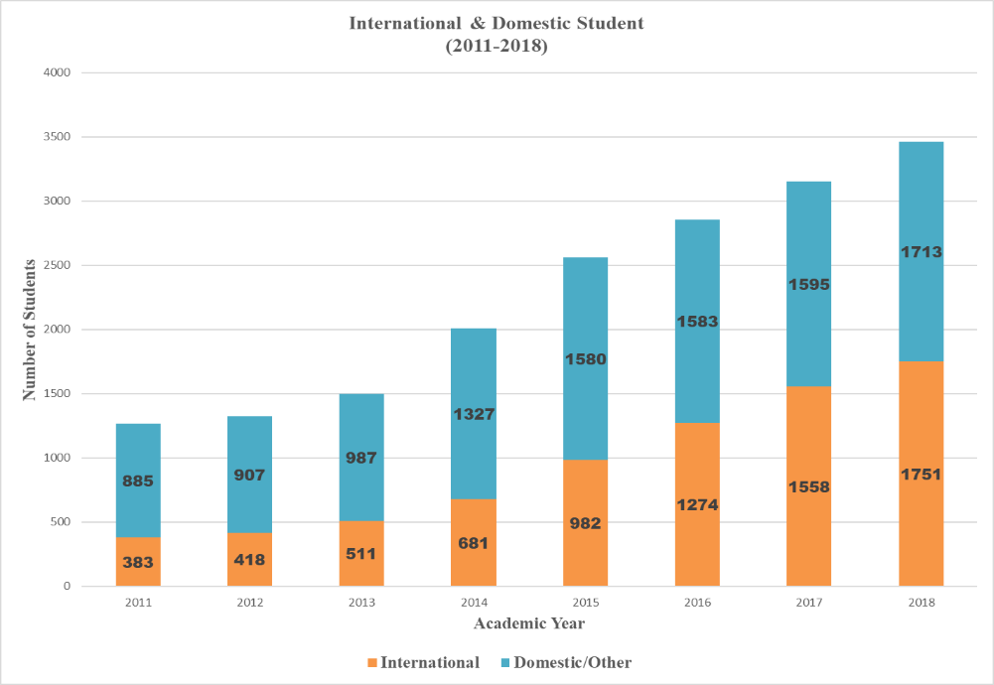

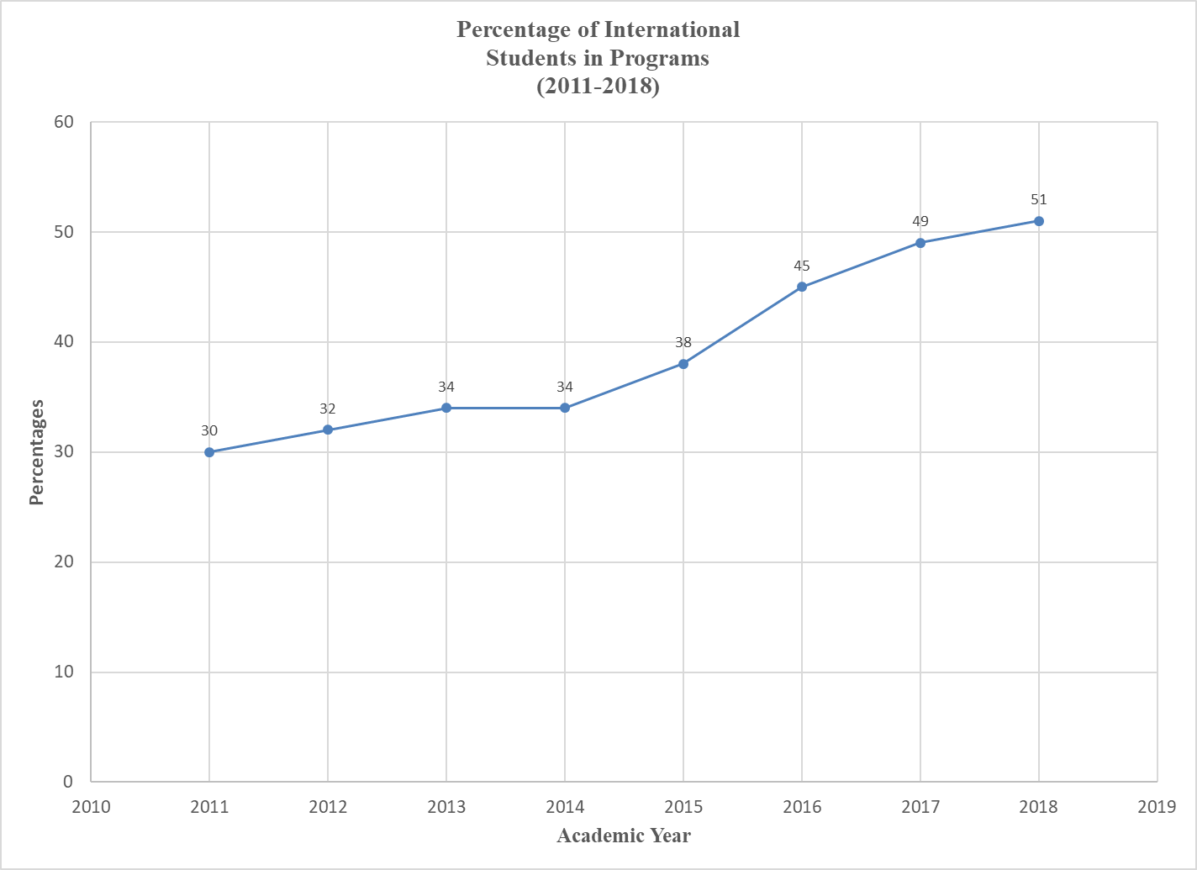

**2018 Graduates**



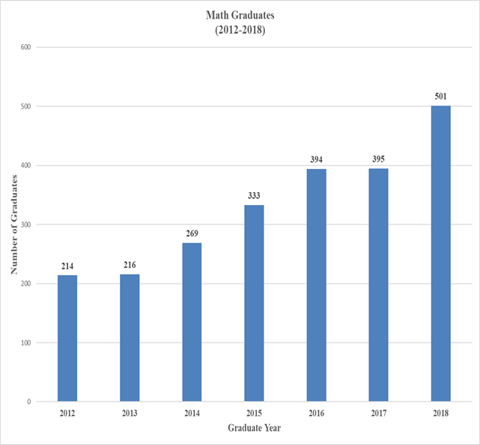

**Other Undergraduate Activities**

* First Year Orientation Sessions were held during the month of August. Sincere thank you to the professors, instructors and students, who took the time to counsel and/or demonstrate actual math content so that incoming first year students may have an idea of the material in the course.
* Summer Student Development Program – With the permission of the Chair, the Field Undergraduate Research Program Administrator and Manager, met with the undergraduate staff and planned a series of math seminars and professional development seminars that were optional for their students to attend. The attendance was much lower than the norm. More than 30 students signed up for each session but in the end the average attendance was 12. This was the first time that development sessions were being scheduled for the summer and it is unlikely that this will be repeated, in light of the low attendance at these sessions.

The sessions were as follows:

* + Maple Computer Math Session – Maple Trainers
  + The Elevator Pitch – Creating a winning personal introduction for interviews by Sheri Crawford, Manager, EDL, User Services, Scotiabank
  + Combinatorial Games – Professor Alfonso Gracia-Saz
  + Advanced Problem Solving – Professor Felix Recio
  + Soft Skills Workshop – Wei Huang, Career Centre Specialist
  + Math Presentation Workshop – Professor Almut Burchard & Professor Alfonso Gracia-Saz
  + Intercultural Workshop – CIE Staff (FURSP session was held and Math session was cancelled)
  + Math Alumni Talk – Eric Hart, Data Scientist, Alik Sokolov (Data Science) and Jongjuk Yang PDF, Dynamical Systems
  + MRI and Math – Professor John Bland
  + Math at Work – Carlo Lisi, Senior Audit Group Manager, TD
  + Applied Partitioning – Assaf Bar-Natan
* Peer Study Teams (PST) – The Faculty of Arts and Science is now in the process of redesigning this project.
* First-year Learning Communities – The MAT137Y1 and MAT157Y1 FLC communities are currently thriving with faculty supervision from Professor Alfonso Gracia-Saz and Professor Joe Repka.
* The FAS continues to host the Backpack to Briefcase (b2B) sessions.

**Data Source For Graphs:** FAS Reports by FAS Manager, Extracts from ROSI, FAS Enrollment Count Reports, Timetabling Tool and Degree Navigator.

1. Nov Count 2018 not yet available, data will be adjusted when available.