**First Year Course Coordinators**

The Department of Mathematics welcomed new staff members who have assumed coordination duties for some of the largest courses in the undergraduate program. These individuals along with some of the others who have done this before worked hard to enable a smooth start to the semester, adjusting schedules, classrooms and demands in order to utilize the limited resources. Thanks to:

Abe Igelfeld – MAT133Y1 906

Sarah Mayes-Tang - MAT135H1 2605

Alfonso Gracia-Saz- MAT137Y1 1258

Joe Repka - MAT157Y1 186

Nicholas Hoell – MAT223H1 1483

Eckhard Meinrenken – MAT240H1 191

**Large second term courses:**

Nicholas Hoell – MAT223H1 735

Jason Siefken – MAT224H1 910

Steve Kudla – MAT247H1 200

**More Data On the Teaching**

There are 158 lecture sections for 2017-2018 Faculty of Arts and Science courses, including four first year seminar courses and 48 lecture sections of Engineering courses.



Summer Lecture Sections



**Teaching Categories**

Professors account for the largest group of instructors.

* Professors: 37
* Retired Professors: 2
* Lecturers: 7
* Graduate Students: 31
* Postdoctoral Fellows: 23
* Unit 3 & Cox: 3

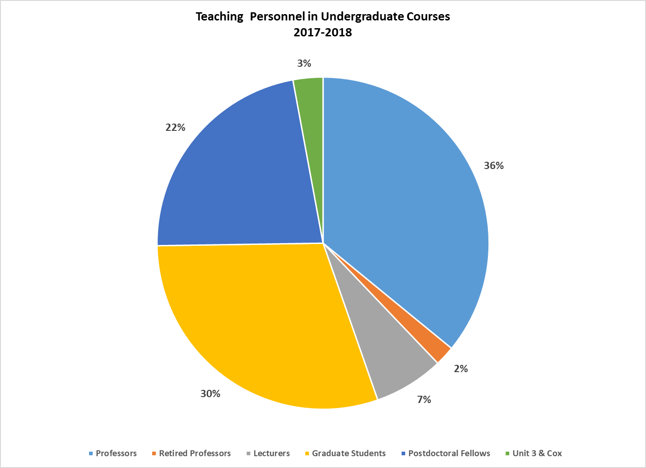

**Program Enrolment**

This year the Department of Mathematics is the second largest department in terms of undergraduate enrolment with 3153 students registered students. The Statistics Department hold the number one spot with a grand total of 3937.

How do our numbers compare with some of the other science departments?

1. Human Biology 3003
2. Commerce 2027
3. Computer Science 2383
4. Economics 1981
5. English 1895
6. Physics 520
7. Chemistry 465

How does this year’s program enrolment compare to previous years?



**Last year’s numbers**

Growth was experienced by Statistics, Math, Computer Science and Commerce all the other departments experienced as reduction in enrolment. Last year the Department of Statistics had 3,225 students in

their program this year they grew by 712 students. Commerce had 1, 954 students they grew by 73, Computer Science grew by 212 from 2, 171, Human Biology fell from 3,118 by 115, Physics fell by 19 and Chemistry fell by 15 and English fell by 254 from 2149.

**Slowing Growth in Math Enrolment**

Ten years ago the department had less than 1000 students registered in programs that amount has more than tripled. Although we continue to grow, the rate of growth has been slowing over the last four sessions.

* Fall 2017 – Growth of 10% over the previous fall session
* Fall 2016 – Growth of 12% over the previous fall session
* Fall 2015 – Growth of 28% over the previous fall session
* Fall 2014 – Growth of 34% over the previous fall session

We’ve certainly seen growth in our own program over the years. Changes in the demand for math in other programs have also led to larger enrolment numbers in math courses.

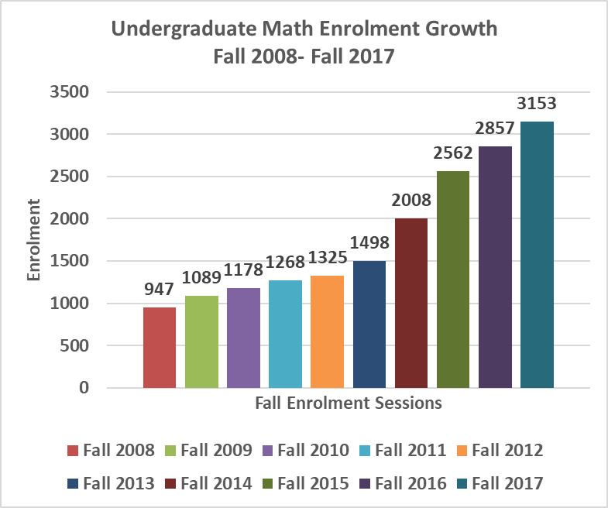

**How Many Students Are in the FAS Classes?**

The data in the table below shows the number of enrollments in some the Faculty of Arts and Science courses as at February 1, 2017. In February, Mathematics courses accounted for the largest percent of Total Arts Sci. courses by any department.

The numbers are not yet available for the fall 2017 enrolment.

| **Department** | **Abbreviation** | **Number of Students** | **FCE’s** | **% of Total Arts Sci FCEs** |
| --- | --- | --- | --- | --- |
|  |  |  |  |  |
| Anthropology | ANT | 3836 | 2538 | 2.1 |
| Astronomy | AST | 3112 | 1570 | 1.3 |
| Cells and Systems Biology | CSB | 2650 | 1448 | 1.2 |
| Ecology and Evolutionary Biology | EEB | 2240 | 1141.5 | 0.9 |
| Human Biology | HMB | 4439 | 2274 | 1.9 |
| Chemistry | CHM | 5210 | 2709.5 | 2.2 |
| Commerce | COM |  |  |  |
| Computer Science | CSC | 14751 | 7354.5 | 6.0 |
| Economics | ECO | 11251 | 8806 | 7.2 |
| English | ENG | 5287 | 3743 | 3.1 |
| Mathematics | MAT | 16437 | 10012 | 8.2 |
| Physics | PHY | 4397 | 2198.5 | 1.8 |
| Political Studies | POL | 6118 | 5160.5 | 4.2 |
| Psychology | PSY | 9453 | 4763 | 3.9 |
| Sociology | SOC | 6915 | 3922 | 3.2 |
| Statistics | STA | 7475 | 3749 | 3.1 |

**Enrolment by Gender**

The enrolment by gender data does not account for all the students enrolled in the program since some students did not declare a gender; 1756 of them declared male as their gender and 1389 declared female as their gender.

In fall 2015 the number of males in the program stood at 57.7%, in fall 2016 the number of males in the program moved to 57% and this year the males account for 56%.

**International Student Enrolment in Programs**

The number of international students in the program has quadrupled between 2011 and 2017. International students now account for 49% of the total number of students enrolled in mathematics programs.



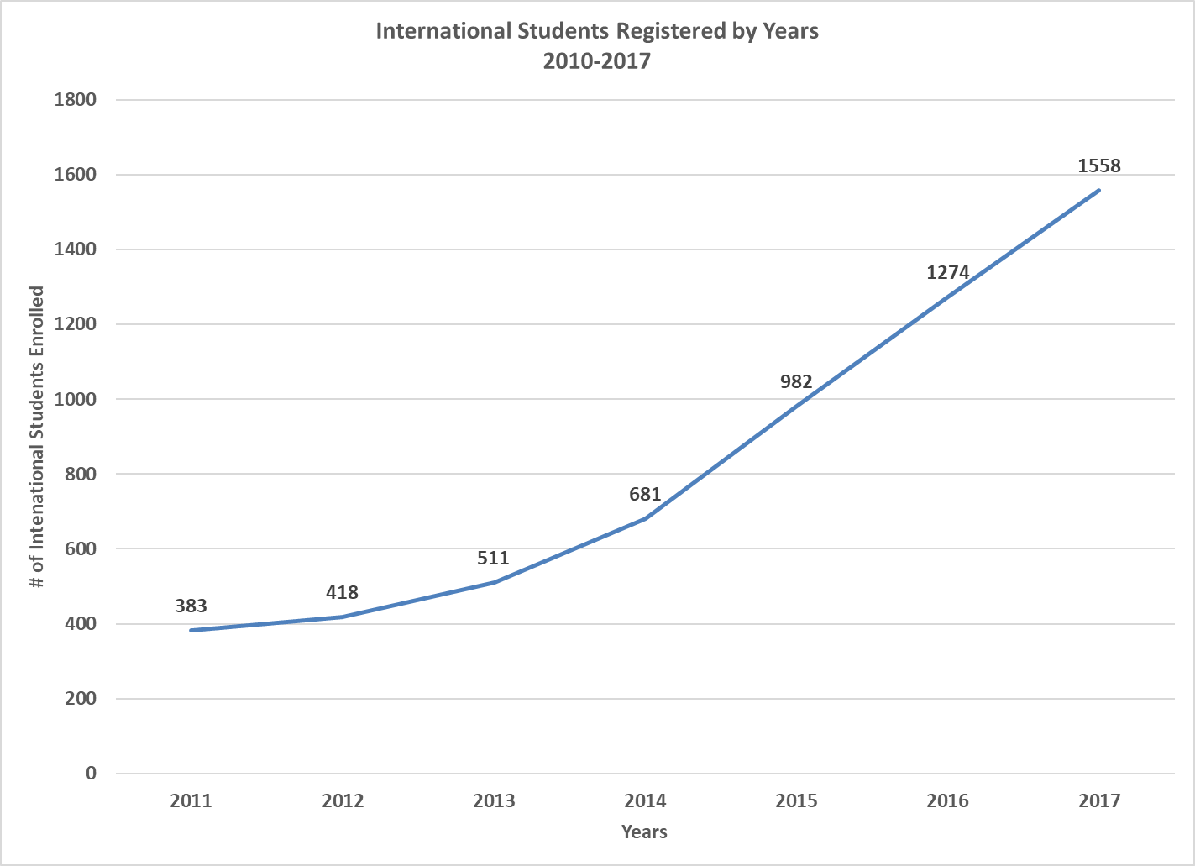

**Graduates 2016 & 2017**

| **Program of Study** | **June + November 2016** | **June 2017** |
| --- | --- | --- |
| Math Major | 117+34 | 115+? |
| Math Minor | 141+26 | 182+? |
| *Sp: Math & Physics* | 8+2 | 8+? |
| *Sp: Mathematics* | 8+1 | 15+? |
| *Sp: Math & Philosophy* | ? | 2+? |
| Sp: Math & its Appl. Teaching | 1+0 | 4+? |
| Sp: Math. Appl. to Econ & Finance | 37+7 | 49+ |
| Sp: Math & its Appl. Physical Sci. | 2+0 | 1+? |
| Sp: Math & its Appl. Prob. & Stats. | 7+1 | 15+? |
| *Sp: Applied Mathematics* | 2+0 | 4+? |
| Total | 272+61=333 | 395 |

**2012-2017 Graduation Totals**

Please note that the Chart for 2017 on shows the June 2017 graduation total. This will be amended to show the full amount as soon as the November math graduate total is available.

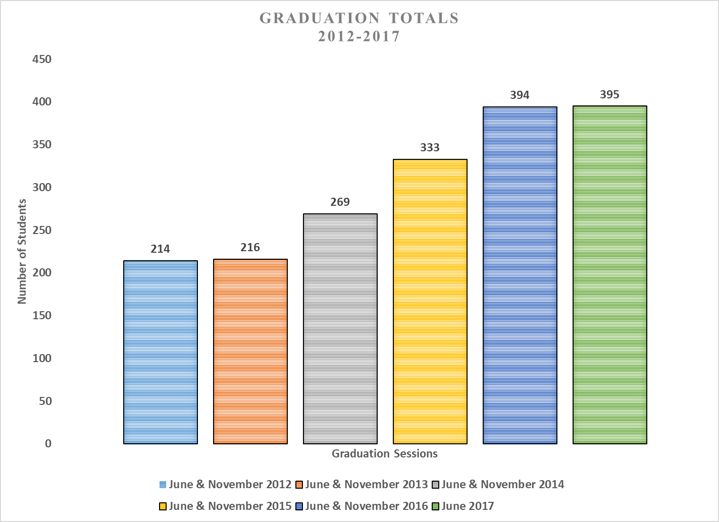

**Other Undergraduate Activities**

The Department of Mathematics continue to execute programs that focus on enhancement of the students’ experience.

* First Year Orientation Sessions – We held two sets of orientation session July and August. Sincere thank you to the Professors and instructors who took the time to counsel and/or demonstrate actual math content so that students may have an idea of the material in the course.
* Career development workshops and programs – No career development workshop were held last year
* Mentorship connections – The mentorship program grew to 46 pairs in 2017-2018. The mentee launch event will be held on October 26, 2017 and the MentorConnect session will take place in November. We are still inviting faculty participation in the mentorship activities.
* Peer Study Teams (PST) – The faculty of arts and Science has included MAT157Y, MAT240H1 and MAT247H1 in their Peer Study Team Project.
* Co-Curricular Credits awarded
* First-year Learning Communities – The MAT137Y and MAT157Y1 FLC communities are currently thriving with faculty supervision from Professor Joe Repka and Joel Kamnitzer.
* Backpack to Briefcase (B2) sessions
* PUTNAM Competition
* Undergraduate Math Competition