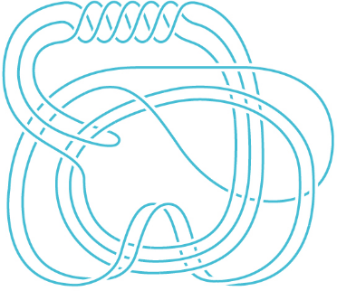
A Short Course On “Fast Computations in Knot Theory”
Dror Bar-Natan at Tsuda University, June 29 – July 10, 2023.
Tagline. A half is better than a whole!
Idea. Do the computational side of Piccirillo’s “The Conway Knot is Not Slice”, Ann. of Math. (2) 191(2): 581-591 (March 2020), arXiv:1808.02923 (see also an article in Quanta Magazine).
Course Purpose and Content / Learning Objectives. Learn about the Jones polynomial and about Khovanov homology, and how to compute them, and how to use “tangles” to compute them even faster. Along the way learn a bit about homology theory and about category theory. Actually implement some of the algorithms learned!
Piccirillo's Knot (Quanta Magazine)

Preliminaries. Absolute confidence with linear algebra: vector spaces, linear transformations, kernels, images, Gaussian elimination. Better if you know “tensor product” and “homology” even if just barely.
Reading Preliminaries. Before the start of the course you must read the Quanta Magazine article (even without fully understanding it), and you should skim through the Piccirillo paper.
Tentative Hourly Plan.
Jones | Khovanov | Piccirillo

- A quick introduction to knot theory.
- The Jones polynomial.
- Computing the Jones polynomial.
- A half is better than a whole: Computing the Jones polynomial much faster.
- Cows are better than numbers! Complexes are not so bad either.
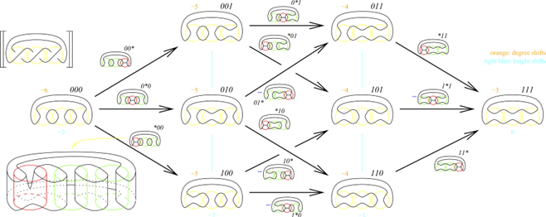
- Khovanov homology: The definition.
- Homology of spaces.
- How to prove things about complexes?
- Khovanov homology: Invariance.
- Khovanov homology: Computation.
- Categories and complexes in a category.
- Homotopy in topology and in algebra.
- Khovanov homology for tangles.
- Formal Gaussian elimination and delooping.
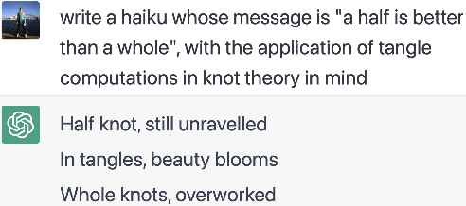
- FastKh / a meta-half is better than a meta-whole.
Evaluation Method. Attendance (40%) and Homework (60%).
References.
- Dror Bar-Natan, “On Khovanov's Categorification of the Jones Polynomial”, Algebraic and Geometric Topology 2-16 (2002) 337-370 and http://www.math.toronto.edu/~drorbn/papers/Categorification/.
- Dror Bar-Natan, “Khovanov's Homology for Tangles and Cobordisms”, Geometry and Topology 9-33 (2005) 1443-1499 and http://www.math.toronto.edu/~drorbn/papers/Cobordism/.
- Dror Bar-Natan, “Fast Khovanov Homology Computations”, Journal of Knot Theory and Its Ramifications, 16-3 (2007) 243-255 and http://www.math.toronto.edu/~drorbn/papers/FastKh/.
- Allen Hatcher, “Algebraic Topology”, https://pi.math.cornell.edu/~hatcher/AT/ATpage.html.
- Mikhail Khovanov, “A Categorification of the Jones Polynomial”, Duke Math. J. 101 (2000), no. 3, 359-426 and https://arxiv.org/abs/math/9908171.
- Erica Klarreich, “Graduate Student Solves Decades-Old Conway Knot Problem”, Quanta Magazine on May 19 2020 and https://www.quantamagazine.org/graduate-student-solves-decades-old-conway-knot-problem-20200519/.
- Louis H. Kauffman, “On Knots”, Princeton University Press 1988.
- W. B. Raymond Lickorish, “An Introduction to Knot Theory”, GTM 175, Springer 1997.
- Lisa Piccirillo, “The Conway knot is not slice”, Ann. of Math. (2) 191(2): 581-591 (March 2020) and arXiv:1808.02923.

