Wanted

by the Excision Authorities of Algebraic Topology

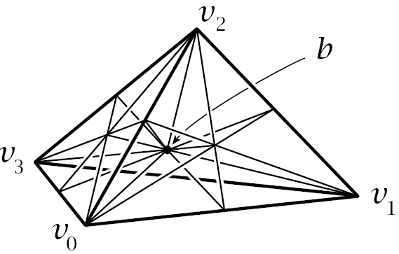 |  |  | 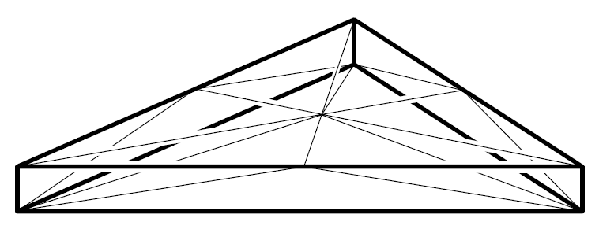
 | S | and |  | T

- Both map affine chains to affine chains with lesser support!
- Both commute with affine-linear transformations!
- S breaks any simplex of dimension n into a sum of simplices of diameter at most n/(n+1) its original diameter!
- $∂S=S∂$and $S-I=T∂+∂T.$

Image credits: Hatcher's book, http://www.math.cornell.edu/~hatcher/AT/ATpage.html.

