Dror Bar-Natan: Academic Pensieve: 2012-12: NCGE:

The Back Side

A homomorphism from S4 to S3:

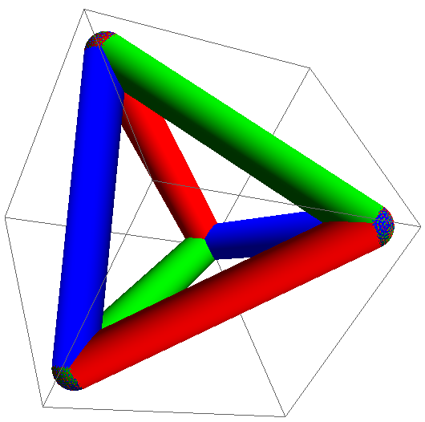

A homomorphism from A5, to the symmetry group of a dodecahedron, to A6:

http://drorbn.net/AcademicPensieve/2012-12/NCGE/

